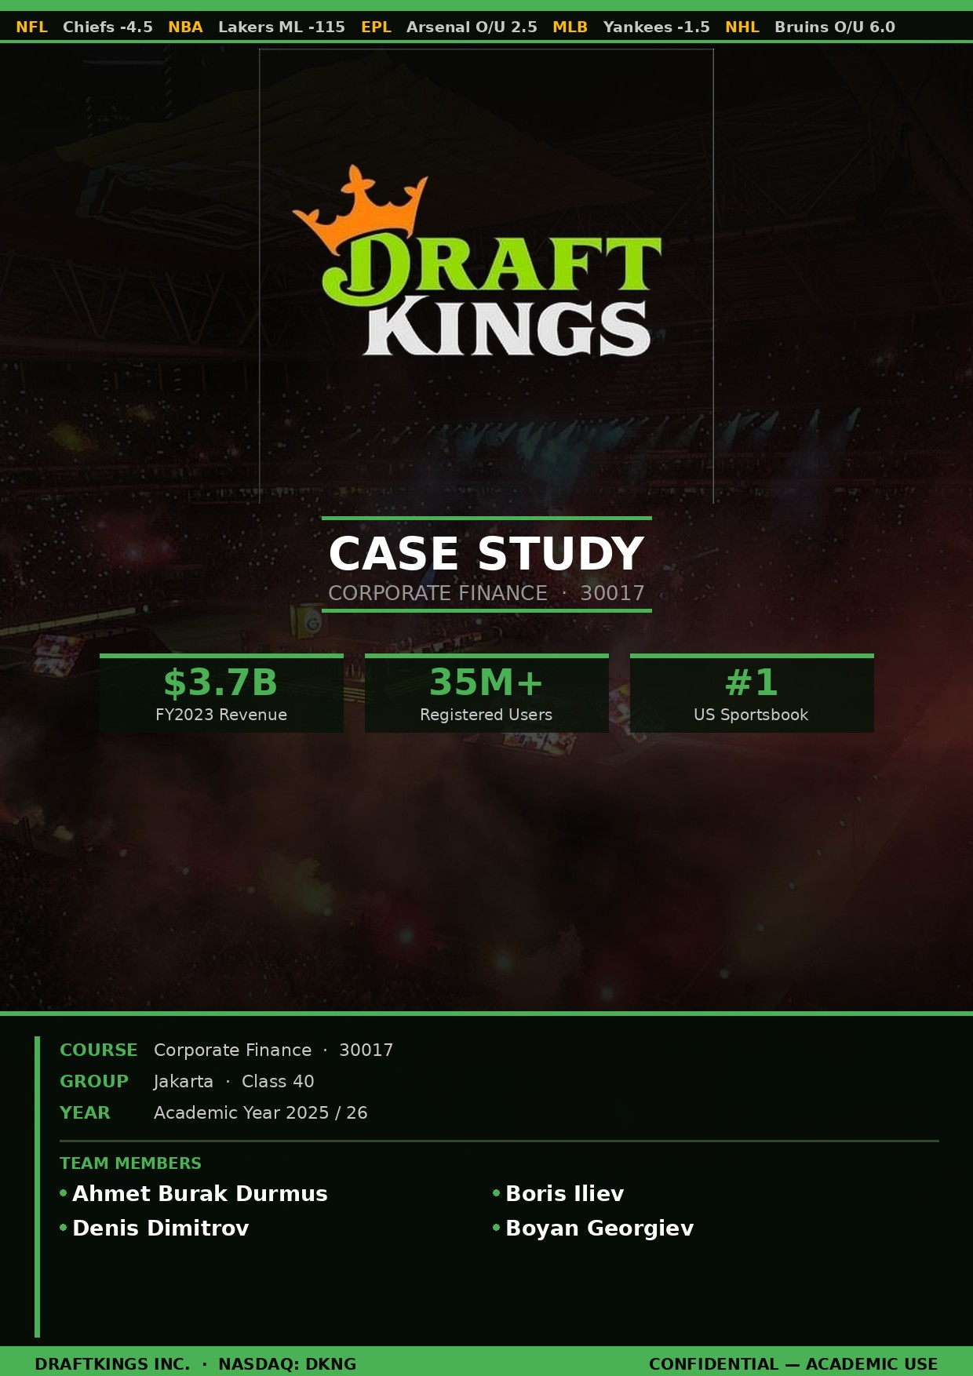

Executive Summary
DraftKings Inc. is a digital sports entertainment company which offers to its customers a variety of mobile apps that allow users to participate in daily fantasy contests, online and retail betting on sports events, and casino-style games. The company is preparing for an upcoming “investor day,” so it is of crucial importance that the firm’s cost of capital be determined in order to guide management in investment decisions such as brand image development, technological advancements, and customer acquisitions throughout existing and new markets. As DraftKings’ business has matured and transitioned to more stable and sustainable operations, it is critical that an appropriate hurdle rate be measured. Given the risk-free rate of 0.9%, an asset beta measured at 1.41, and a market risk premium of 5%, we have estimated DraftKings’ cost of capital rate at 7.95%. Our recommendation is that management use this rate as a benchmark in evaluating new projects, while also being ready to alter and modify strategies when tackling notably different risk profiles.

Summary of Facts
DraftKings was established in 2012 in an apartment in Watertown, Massachusetts, by a group of three friends. The company experienced accelerated growth after the 2018 repeal of the Professional and Amateur Sports Protection Act (PASPA) by the U.S. Supreme Court and by 2020 operated in more states than any other operator on the market. Through a three-way SPAC merger involving SBTech, an online betting engine provider, in 2020 DraftKings was finally able to be listed publicly. This move created a strong vertically integrated model that improved product differentiation and supported higher gross margins by eliminating licensing costs. A number of benefits, including early entry into recently legalized markets, a strong brand image, a data-driven promotional approach, and ongoing investments in R&D and user acquisition, have contributed to DraftKings’ success. However, because of variations in state tax rates, user behavior, and product limitations, project returns might vary. Using CAPM and betas from similar companies in the market, analysts have calculated DraftKings’ cost of capital to be between 7% and 10%. Management is focused on developing a dependable internal cost of capital estimate to guide capital allocation decisions concerning marketing and product expansion campaigns.

Statement of Problem
Since the business is now in a phase where it expands and investors are eyeing up long-term profitability, DraftKings must now come up with a well-grounded estimate of its cost of capital. Despite its strong revenue growth, DraftKings is still experiencing huge losses, especially from advertising and customer acquisition, further proving the importance of disciplined capital allocation (Exhibit 1). This should provide help when determining the best investment options. In order to achieve said goal, the company must compute its WACC while minding the relevant assumptions at hand. After that, the firm should evaluate the returns on future projects against it and decide whether they should go ahead with them or not.

Analysis
DraftKings must be guided by the broad factors of the investment’s returns and its cost of capital while evaluating its investment prospects, whether in brand awareness, advertising, expansion, or technology. All of this is, of course, impacted by cash flow aspects that come from the investments and the risk that accompanies.
DraftKings needs an estimate of the risk-free rate, the market risk premium, and its asset beta in order to calculate the WACC, which in this case includes only equity since the company has no debt. A reasonable assumption for the risk-free rate could be derived from the ten-year Treasury yield. We extrapolate a rate of 0.9 percent (Exhibit 5). Now, when it comes to the market risk premium, we can use the mean from the two surveys directed respectively at CFOs and financial professionals and estimate it at 5%.
Asset betas are calculated using the formula shown below:

Still, as we mentioned above, DraftKings finances only using equity; thus D = 0:
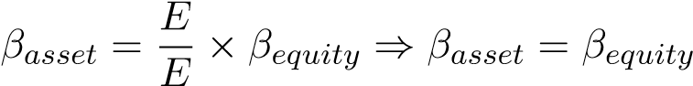
When estimating the asset beta, we have decided to isolate four companies that we have determined to be similar enough in an operational and geographical way.² This is necessary because in order to estimate DraftKings’ beta, the primary option is to use the average of its closest competitors. The four companies that we have decided to use for the comparison are: Caesars, Penn Entertainment, Churchill Downs, and Boyd Gaming, with an average beta of 1.413 (Table 2). From this we can compute the WACC, which is equal to the result of the computation of the CAPM:
re = rf + βDKNG × rp
We get the result 7.95% for the cost of capital of DraftKings (Table 1). Moreover, a threeyear payback implies that the initial investment is recovered after only three years, which on a compounded basis gives us a 26%³ return on investment—well above the aforementioned threshold.

Recommendation
DraftKings should keep investing in customer acquisition and expansion opportunities as long as it continues to keep up a similar return profile, because obtaining new customers shows a three-year gross profit payback, implying an annual return of 26%—well above the WACC of
7.95%.

Footnotes and Tables
¹We use the two surveys in 2021 which showed an estimate of 4.6% by CFOs and 5.5% by investment professionals, roughly leading to a 5% market risk premium.
²These companies are the ones that make their revenue primarily by some kind of gambling operation (racing included) and are solely based in the U.S. ³(1 + r)³ = 2 ⇒ r = 0.26
Table 1: Estimate of DraftKings’ WACC
Unit | Value
Risk-Free Rate [%] | 0.90
Market Risk Premium [%] | 5.00
Asset Beta [#] | 1.41
WACC [%] | 7.95
Table 2: Estimates of Weighted Average Cost of Capital (WACC) for comparable firms
Debt ( $M) | Equity  ( $M) | E/ (D+E) | D/ Debt  Rating  (D+E) β |  | Equity β | Asset β | WACC
Penn Entertainment 10,906 | 13,448 | 0.552 | 0.448 | B 0.41 | 2.79 | 1.725 | 0.095
Caesars 26,813 | 15,452 | 0.366 | 0.634 | B 0.41 | 3.14 | 1.409 | 0.079
Churchill Downs 1,643 | 7,694 | 0.824 | 0.176 | BB 0.35 | 1.36 | 1.185 | 0.068
Boyd Gaming 4,716 | 4,800 | 0.504 | 0.496 | B 0.41 | 2.24 | 1.332 | 0.076
 |  |  |  | Average | 1.413
Table 3: Regression Outputs for Comparable Companies (2016–2020)
Company | R2 | Std. Error | βE
Caesars | 0.379 | 0.147 | 3.144
Penn Entertainment | 0.339 | 0.158 | 2.792
Churchill Downs | 0.425 | 0.070 | 1.363
Boyd Gaming | 0.321 | 0.096 | 2.241
Note: Equity beta estimates were obtained as the slope coefficient of a regression of company stock returns on stock market returns over the period 2016–2020.

